

Practices for Secure Software Report

Table of Contents
Document Revision History 3
Client 3
Instructions Error! Bookmark not defined.
Developer 4
1. Algorithm Cipher 4
2. Certificate Generation 4
3. Deploy Cipher 4
4. Secure Communications 5
5. Secondary Testing 5
6. Functional Testing 6
7. Summary 6
8. Industry Standard Best Practices 6

Document Revision History

Version | Date | Author | Comments
1.0 | 06/19/2026 | Michael Miller

Client



Developer
Michael Miller

Algorithm Cipher

For this project, I implemented a SHA-256 hashing algorithm to securely transform input data into a fixed-length hash value. This algorithm ensures that sensitive information is never stored or transmitted in plain text. The hashing functionality was added through a dedicated controller that accepts a data parameter, processes it using SHA-256, and returns the resulting hash in JSON format. This provides a reliable and secure method for verifying data integrity.

Certificate Generation
Insert a screenshot below of the CER file.

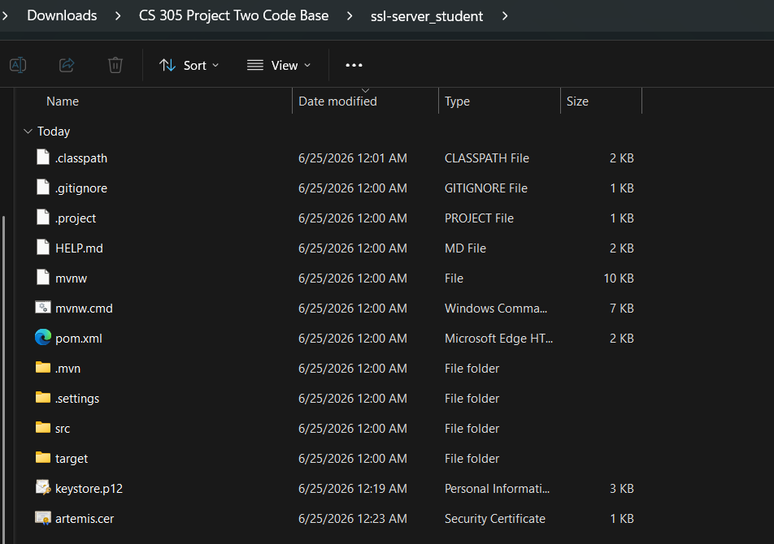

Deploy Cipher
Insert a screenshot below of the checksum verification.



Secure Communications
Insert a screenshot below of the web browser that shows a secure webpage.

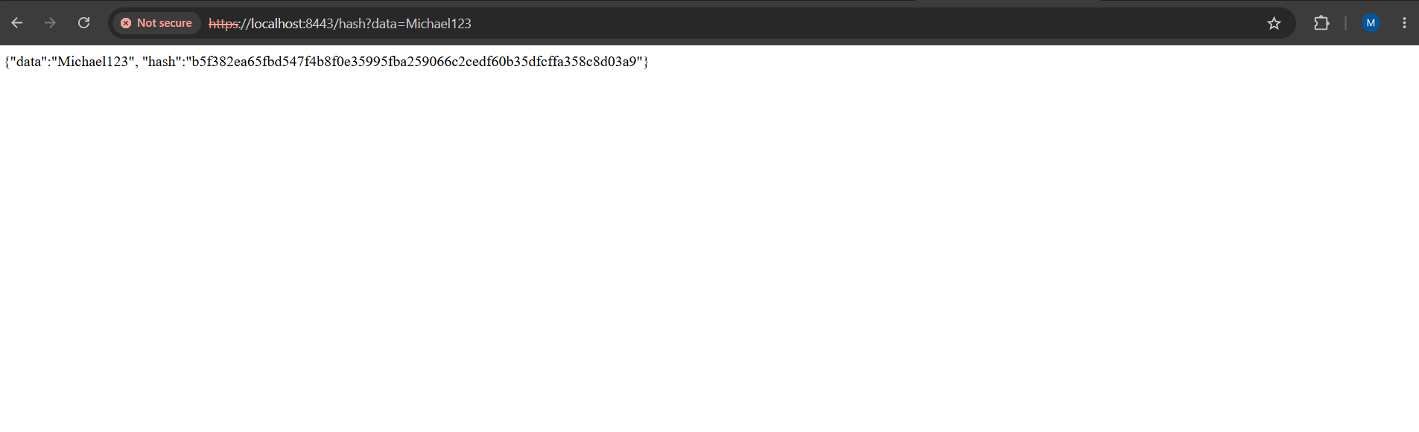

Secondary Testing
Insert screenshots below of the refactored code executed without errors and the dependency-check report.

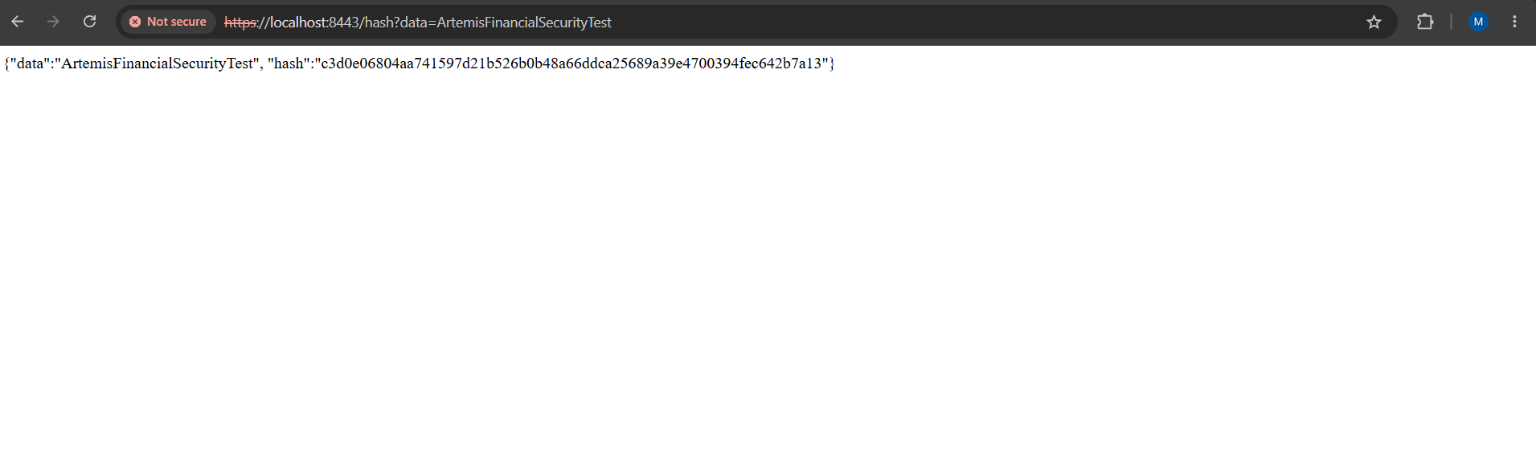
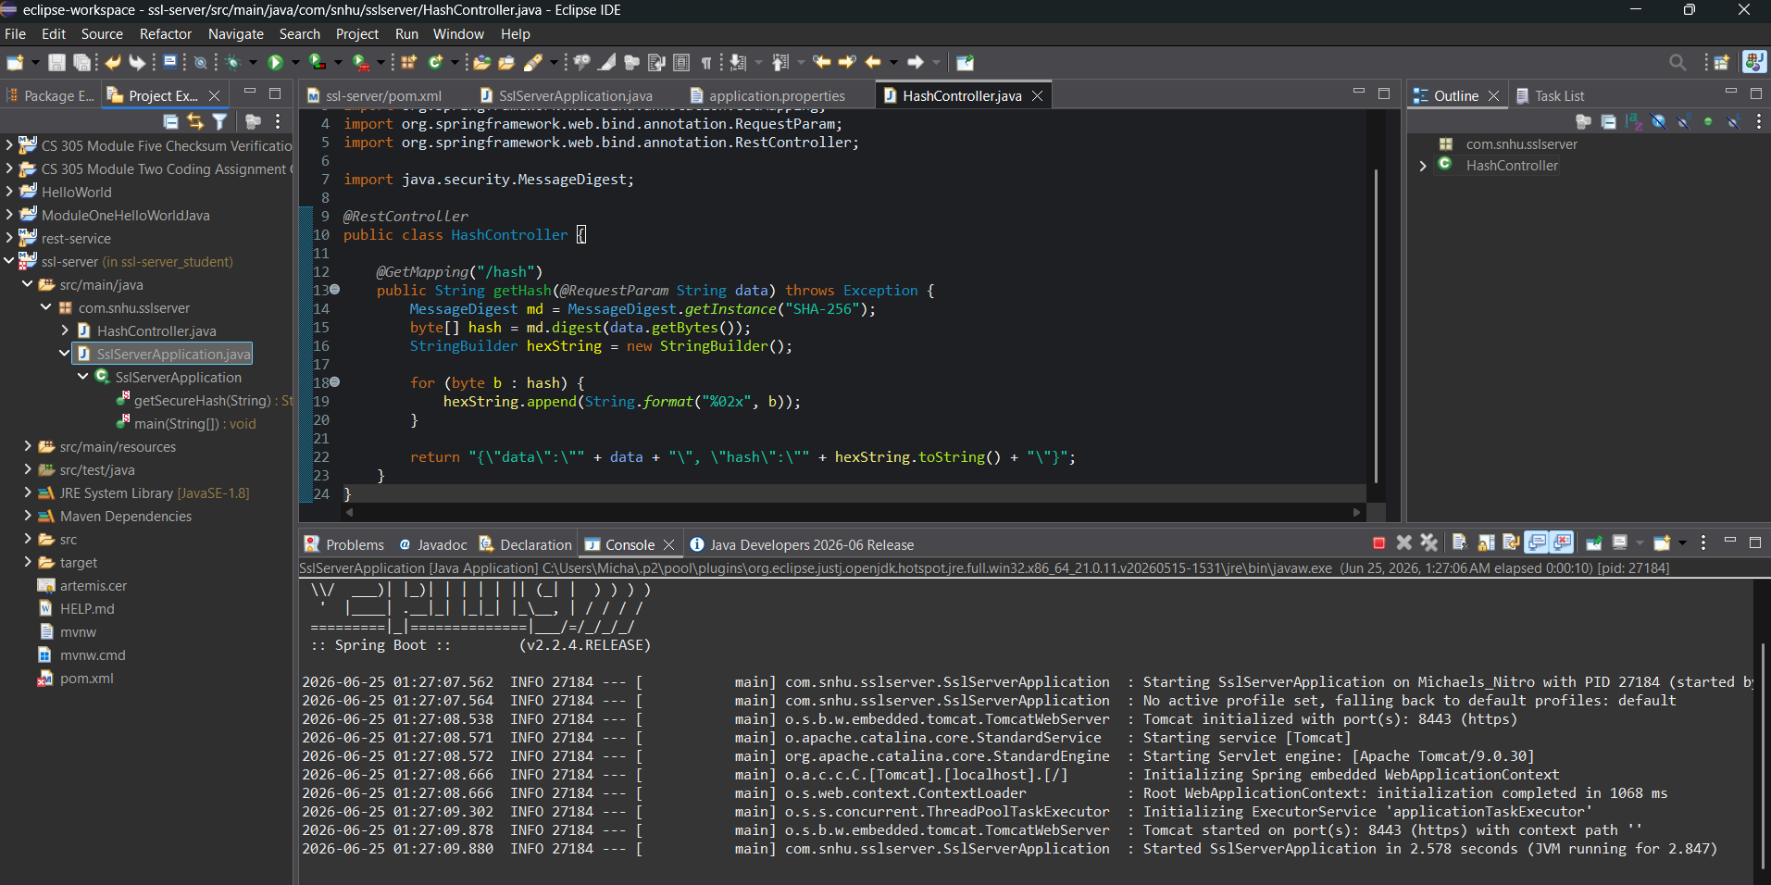

Functional Testing
Insert a screenshot below of the refactored code executed without errors.

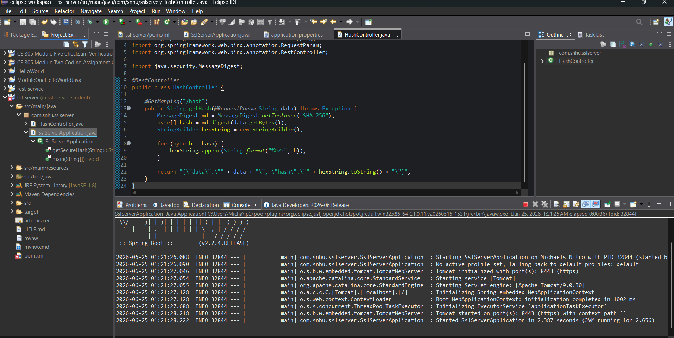

Summary

This project focused on improving the security of Artemis Financial’s web application by implementing secure communication, adding a hashing function, and updating the application to follow secure coding practices. The SHA-256 hashing algorithm ensures that sensitive information is transformed into a secure, irreversible format. Enabling HTTPS through certificate generation and configuration protects data transmitted between the client and server. Testing confirmed that the application runs without errors, produces correct hash values, and communicates securely over HTTPS. These improvements strengthen the overall security posture of the application and help protect client data.

Industry Standard Best Practices

Several industry standard best practices were applied during this project. Enabling HTTPS aligns with modern security expectations for encrypted communication. Using SHA-256 follows widely accepted cryptographic standards for hashing. Updating dependencies reduces exposure to known vulnerabilities. Testing the application after each change ensures that functionality remains stable and secure. Together, these practices support the development of reliable, secure software that meets professional expectations.

